# GAMLE4 – Feature doc – Wood chip (stealth map)

## Why? / Summary

A player power that can be thrown in a controlled radius and teleport to it.

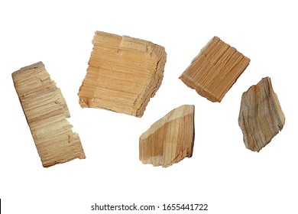

## Goals

* Have a powerup that allows the player to traverse through challenges in the map in a wise way
* Have a powerup that has multiple ways and places of being used
* Powerup should be easy and intuitive to use
* Should be used sparingly / strategically

## Feature breakdown

This feature would be in specific places where the player can pick them up. If the player picks them up, they have a choice of lighting it on fire whenever they wish.

To light it on fire and place, choose where it should go when a button is pressed.

To throw the lit wood chip, the same button needs to be pressed again.

After throwing it, the wood chip is no longer available to throw unless another wood chip is picked up again (inventory like item but only one spot for it).

The player lights a wood chip on fire and becomes that wood chip, but the fire/object they were before loses the flame after the wood chip is thrown to indicate that the player now is the wood chip. The camera follows the thrown wood chip.

Controls:

* Pressing ‘G’ will place the wood chip at the mouse location
* Pressing the ‘G’ again will throw the wood chip and start the teleport

Mechanics:

* When used over allowed walls, the player can surpass walls or land on top of some objects
* When the user throws it in front of an enemy they get seen and killed immediately
* Can be used to surpass enemies (jump over them)
* Can only be used if picked up, and you have maximum one of them at all times (like ammo but only one)

Art:

* The wood chip should start unlit and when the player wants to throw it, it should catch fire from the player (the player lights the wood chip with themselves)
* You should be able to see the wood chip fall in an arc to the desired teleport point, it also shows that arc with a red line that disappears after a second
* When the lit wood chip lands it should create small spark on the floor/walls (can be throw against tall walls but will ricochet back down)

Sound:

* A sound of the wood chip being lit on fire should be heard (whooshing sound)
* A sound of the wood landing should be heard (fire spark sound)

## Stats

Distance: it can be thrown: 5 blocks maximum (1 block is 1 meter)

~~Bounces: The bounce (distance not height) will be halved. If thrown 5 blocks, will travel 5 blocks towards the wall and bounce back 2.5 blocks back.~~

~~In air time: 0.5 second in the air for 1 block of distance. If thrown 5 blocks it will be in the air for 2.5 seconds.~~

The Wood chip respawns after 5 seconds of it being picked up.

## Backstory

During the vicious house fire, wooden parts of the house fell everywhere.

## Flags